Lesson 5
Analysis of sulfur-containing functional groups
Drugs with sulfur-containing functional groups include some amino acids, sulfonamides, dithiocarbamic acid derivatives, benzosulfonic acid derivatives, sulfanilic acid derivatives, thiazolidine derivatives, penicillins, cephalosporins, etc. Many reactions are used to determine sulfur functional groups, for example, reaction with Na-nitroprusside, halogenation , drying with NaOH, reaction with ninhydrin, with oxidizing agents, with Na₂CO₃ and NaNO₃, with CuSO₄, with KNO₃ and HNO₃, etc.
The reaction with Na-nitroprusside gives some amino acids, sulfonamides, thiazolidine derivatives.
The halogenation reaction is given by sulfonamides, representatives of amino acids (containing S), phenothiazine derivatives.
The reaction with ninhydrin gives sulfonylurea derivatives, cephalosporins.
The reaction with NaOH and CuSO₄ gives sulfonamides, cephalosporins, sulfonylurea derivatives.
The reaction with NaCO₃ + NaNO₃ gives derivatives of sulfonyl acid, sulfocamphoric acid, phenothiazine derivatives.
- Thiourea (H₂N-CS-NH2)

II. Sulfonamides (R-SO2-NH2)
1. With N,N-dimethyl-1-naphthylamine and sodium nitrite give red-pink products. For this, specially prepared indicator papers are used.
Progress of work: a few drops of a suspension of the sample in water are applied to the indicator paper. The stains obtained are acidified with 2-5% hydrochloric acid. The appearance of a red ring indicates the presence of sulfanilamide.
2. Sulfonamides form sodium sulfite and ammonia when dried with NaOH (streptocide).
3. Reaction with Na-nitroprusside - alkaline solutions of sulfanilamide preparations give a red color or precipitate when acid is added with a 1% solution of Na-nitroprusside (streptocide).
4. Washed with NaOH solution and filtered; adding 1 ml of copper sulphate solution to the filtrate gives a colored precipitate. For example, sulfadimezin, sulfadimethoxine first give a yellow-green, then a brown precipitate, and norsulfazol gives a dirty purple color.

5. Halogenation reaction - as a result, dibromine or diode derivatives are formed.
6. Determination of sulfur. Sulfanilamide is boiled in concentrated nitric acid or calcined with potassium nitrate weighing 10 times the weight, then the reaction is carried out for sulfates (barium chloride).
III. Sulfides (A-S-A)
1. When dissolved with NaOH, they give Na-sulfide. When the mixture is acidified, hydrogen sulfide (gas) is released with a characteristic odor.
2. Oxidized by permanganate K, it turns into sulfones
A-S-A ------- A-SO₂-A
Progress of work: 1 drop of KMnO4 solution is added to a solution of 20-25 mg of a sample in 0.5 ml of acetic acid; the disappearance of the color indicates the presence of sulfur in the sample.

IV. Disulfides (A-S-S-A)
- Easily reduced to thiols and examined by the resulting thiol.
A-S-S-A + H₂N-OH HCl + Zn ------ A-SH (tiol)
Progress of work To 10 ml of the sample, add 1 ml of a solution of hydroxylamine hydrochloride in 1N methanol solution and a few mg of zinc. Wait until the complete precipitation of zinc dust, remove the supernatant and carry out the reaction for thiols.
Disulfides include teturam (a derivative of dithiocarbamic acid).
- Melt with KOH, dissolve the alloy in water, add a solution of lead acetate, a black precipitate precipitates.
- K₂S + Pb(CH₃COO)₂ ------PbS + CH₃COOK
3. When interacting with bromine water, a reaction associated with sulfates occurs.
V. Sulfonic acids (R-SO3H)
Sulfonyl acids are converted to sulfonyl chloride with the help of thionyl chloride. It then reacts with concentrated ammonia to form a sulfonamide. This is revealed using special marker paper.
Ar-SO₃H + SO₂Cl ------ Ar-SO₂Cl ----- Ar- SO₂NH₂
Progress of work: 100 ml of a sample for analysis with 10 drops of thionyl chloride is placed in a dry test tube and heated for 10 minutes. Cool down. Alkalized with concentrated ammonia solution and after 10 minutes. reheat and filter the formed precipitate. The precipitate is dissolved in 0.2% hydrochloric acid and dripped onto marker paper. A red or dark pink color indicates the presence of a sulfonamide.

VI. thiols (mercaptans) (R-SH)
Although low molecular weight thiols are very slightly soluble in water, they form salts when dissolved in a NaOH solution.
1. Formation of lead mercaptides
Work progress: 2 drops of the sample are added to 5 ml of a saturated solution of lead acetate in alcohol, if a yellow color is obtained, the reaction is positive.
2. Formation of lead sulfide
Progress of work: Add 1 drop of the sample to 2 ml of Na-plumbite (NaOH+PbO) solution. When a yellow color (lead mercaptide) appears, 50 mg of powdered sulfur is added to the mixture. If the color first turns yellow and then black, the reaction is positive.
3. Mercaptans with various cations give poorly soluble mercaptides. For example, silver and mercury(II) mercaptides are colorless, while copper(II) and lead mercaptides are yellow.
This reaction gives the purine derivatives mercaptopurine and azathioprine.
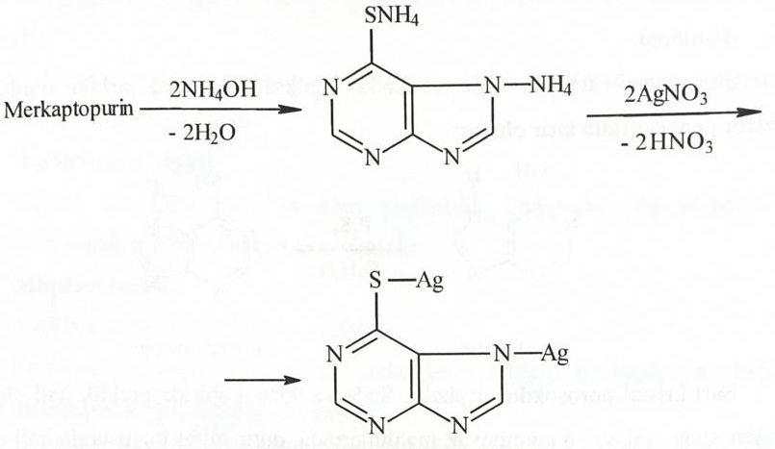
4. Isatin test - thiols give a green color with isatin.
Progress of work: take 3 ml of a sample mixture in ethanol and add 2 ml of a 1% solution of isatin in sulfuric acid to it. Green color indicates the presence of thiol.
5. Oxidation with permanganate (Acetylcysteine. Cysteine).
Organic compounds containing reduced sulfur are oxidized by permanganate to disulfides.
Workflow: 20-25 mg sample is dissolved in 0.5 ml of acetic acid. Potassium permanganate is added dropwise to this solution. Loss of color indicates a positive reaction.
6. Nitroprusside test
Mercaptans give the wine a red color with nitroprusside.
Progress of work: 1% solution of Na-nitroprusside and 3 drops of 10% NaOH are added to 1 mg of the sample, if a wine-red color is obtained, the reaction is positive (cysteine, acetylcysteine, penicillamine).
Cysteine gives a red-violet color in an alkaline environment with Na-nitroprusside (sulfhydryl group). Gives a purple color which quickly disappears with iron(III) chloride (sulfhydryl group).
7. Captopril, a proline derivative, was placed in a 50 ml flask and mixed with 30 ml of water for 5 minutes. It is filtered and the first 15 ml of the filtrate is discarded, 10 ml of a 10% Na-acetate solution, 5-6 drops of a mercury indicator or theophylline azo dye are added to 5 ml of the filtrate, then a 0.02 M solution of mercury (2) nitrate is added. Observe the color transition from yellow to red-violet.
This method also determines cysteine, acetylcysteine and penicillamine.
Mercury complex of acetylcysteine and cysteine
Mercury complex captopril
VII. Thiophenols (Ar-SH)
Due to their aromatic nature, they are easily nitrated and brominated.
They form salts with alkali and heavy metals. Oxidized by strong oxidizing agents to benzenesulfonic acid.
- A solution of chloramine B, an amide derivative of benzenesulfonic acid, first stains red litmus paper blue and then discolors it.
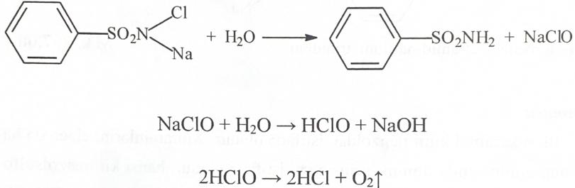
Furosemide
1) When a solution of Furosemide in alkali is heated, it turns blue litmus paper moistened with water.
2) 0.1 g of the drug is boiled with 3 ml of sulfuric acid, cooled, the solution is diluted with water to 10 ml and filtered. In the resulting filtrate, a reaction is carried out associated with sulfates (sulfo groups).
2. Derivatives of sulfonic acids (carbutamide, chlorpropamide)
Carbutamide.
When the drug is heated with a solution of KOH, ammonia is formed as a result of hydrolysis, which is determined by the blue color of red litmus paper soaked in water.
Chlorpropamide.
- when heated with sodium hydroxide, ammonia is released with heating.
- when heated with concentrated sulfuric acid, a precipitate of para-chlorobenzenesulfamide is released (Tmelt = 143-144 C).
3. Sulfocamphoric acid is evaporated in a dish and the residue is calcined in the presence of Na2CO3 and NaNO3. The residue is dissolved in hydrochloric acid and the sulfate ion-specific reaction is carried out.
The same reaction is carried out in the preparation sulfocamphocaine.
VIII. Amino acids (methionine, cysteine, acetylcysteine, penicillamine).
Methionine: 0.05 g of the drug is heated with 30% NaOH solution until melted in the test tube. Cover with filter paper moistened with freshly prepared 5% Na-nitroprusside (Na2Fe(CN)5NO 2H2O) and a red-violet color develops on the filter paper.
5 ml of water are added to the cooled alloy and acidified with sulfuric acid, the smell of hydrogen sulfide and mercaptan (thiomethyl group) is noticeable.
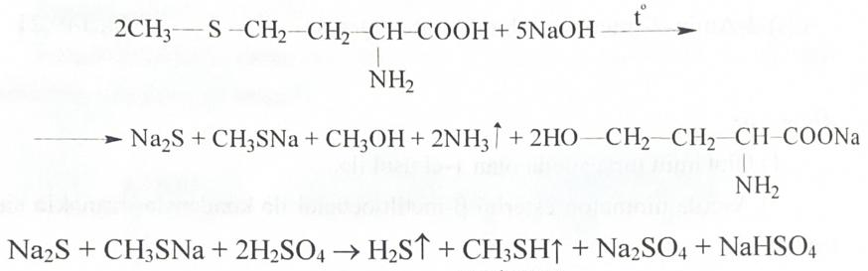
When adding NaOH solution and 20 mg of triketohydrin hydrate to a solution of penicillamine, an intense blue or purple-blue color is obtained.
IX. Phenothiazine derivatives
Phenothiazine derivatives are easily oxidized to form colored products. Bromine water, chloramine B solution, HNO3, iron(3) chloride, H2O2, solid sulfuric acid, etc. are used as oxidizers.
To determine sulfur in the phenothiazine core, the preparations are heated with Na2CO3 and NaNO3, the residue is dissolved in water, filtered, and the reaction is carried out for sulfates.
X. Thiazolidine derivatives (penicillins and cephalosporins).
To determine the sulfur atom in the molecule of penicillins, they are transferred to the sulfur ion by treating with a solution of potassium chloride. The sulfide ion is determined by the formation of a red-violet color with sodium nitroprusside.
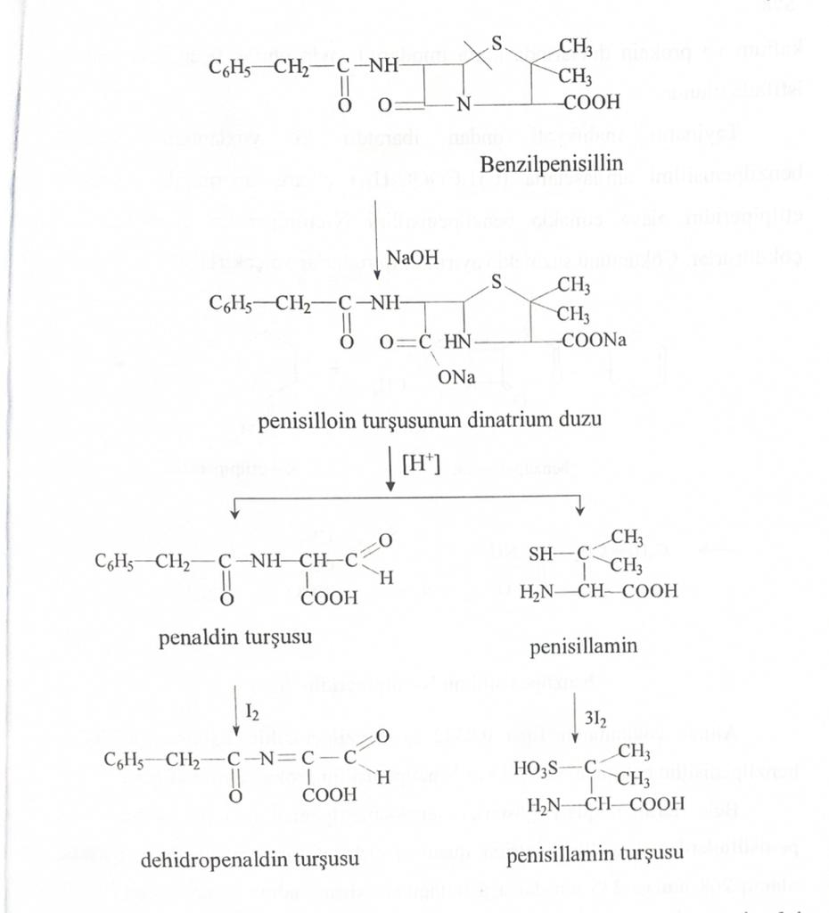
Cephalosporins (cefamezin, cephalexin, cefachlor, ceftazidime, etc.).
Oxidation reactions: 1 drop of 80% sulfuric acid containing 1% nitric acid is added to 0.02 g of the drug in a small bowl. Cephalexin and cephaloridine give a yellow color, and cephalothin Na gives a red-brown to green color.

